TC11, TC12, TC13 and TC14

**Test Scenario:**

* TC11: ESS User able to view contact details
* TC12: ESS User able to edit contact details
* TC13: ESS User able to save edited contact details

**Test Case Steps:**

* TC11:

1. Launch bowser
2. Login to OrangeHRM web portal
3. Click on My Info
4. Click on Contact detail

* TC12:

1. Launch bowser
2. Login to OrangeHRM web portal
3. Click on My Info
4. Click on Contact detail
5. Edit Contact details

* TC13:

1. Launch bowser
2. Login to OrangeHRM web portal
3. Click on My Info
4. Click on Contact detail
5. Edit Contact details
6. Click on save button.

* TC14:

1. Launch bowser
2. Login to OrangeHRM web portal
3. Click on My Info
4. Click on Contact detail
5. Add Employee Replacement Details
6. Click on save button.

**Let’s click on contact details and check whether we are able to view contact details or not (TC11):**

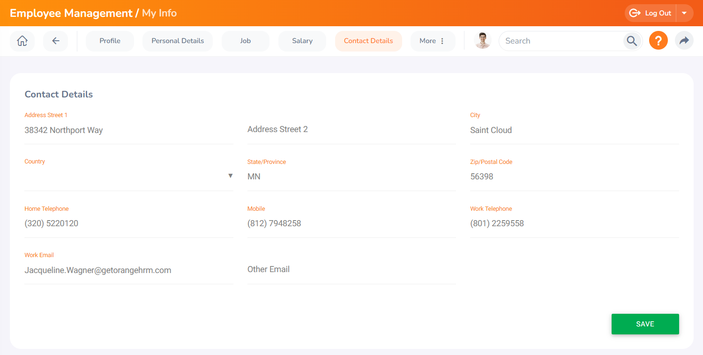

**Here we can view contact details clearly.**

**Now let’s try to edit these contact details (TC12):**

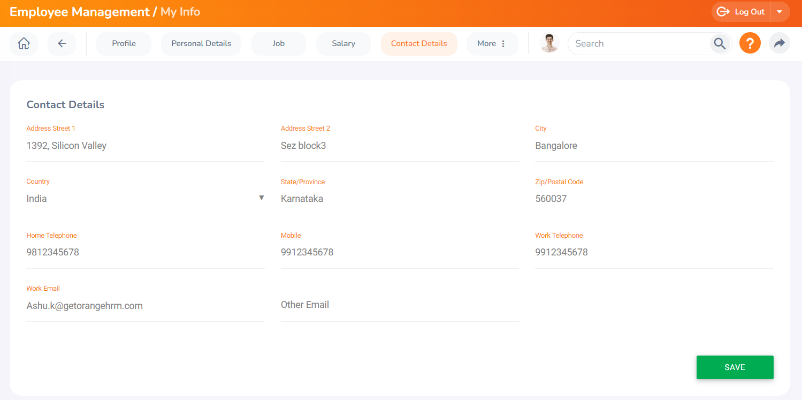

**We are able to edit details.**

**Now let’s try to save these edited details (TC13):**



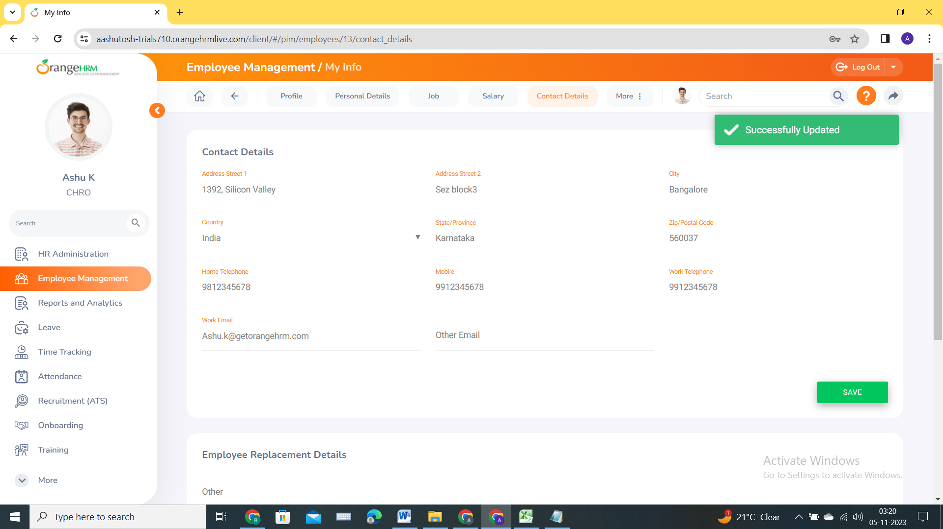

**Details are saved successfully.**

**Now let’s try to add Employee replacement details (TC14):**



